CENWP-OD 09 December 2010

MEMORANDUM FOR THE RECORD

Subject: DRAFT minutes for the 09 December 2010 AFF FPOM task group meeting.

The meeting was held in the NOAA Fisheries St. Helen’s Room, Portland OR. In attendance:
Last | First | Agency | Office/Mobile | Email
Fredricks | Gary | NOAA | 503-231-6855 | Gary.fredricks@noaa.gov
Fryer | Jeff | CRITFC |  | fryj@crtitfc.org
Hausmann | Ben | USACE-BON | 541-374-4598 | Ben.J.Hausmann@usace.army.mil
Lorz | Tom | CRITFC | 503-238-3574 | lort@critfc.org
Mackey | Tammy | USACE-NWP | 541-374-4552 | Tammy.m.mackey@usace.army.mil
Meyer | Ed | NOAA | 503-230-5411 | Ed.meyer@noaa.gov
Whiteaker | John | CRITFC |  | whij@critfc.org
Wills | David | USFWS | 360-604-2500 | David_wills@fws.gov

- Finalized results from this meeting.

- The following documents were provided or discussed. Documents may be found at http://www.nwd-wc.usace.army.mil/tmt/documents/FPOM/2010/
  - 2001 proposed AFF mods- Bret Morgan
  - 2001 proposed AFF mods- Earl Prentice
  - 2009 proposed AFF mods- AFF task group.
  - Frigid Units, Inc tank estimate.
  - Fryer jack analysis.

- Action Items.
  - [Dec 10] CRITFC will develop an ideal trapping facility for discussion.
  - [Dec 10] NOAA will continue to develop the tagged fish analysis.

- AFF update. List of potential improvements attached. The task group will meet after the 9 December FPOM to review the list of potential modifications, discuss those doable in FY11 and potential funding sources. Fredricks said NOAA is seeing lower conversion rates from BON to MCN for fish tagged at BON v those tagged prior to BON. NOAA may submit a change form recommending ceasing sampling at a lower temperature. FPOM will be the venue for determining the temperature limitations for NOAA permits.
  - Anesthetic tank. Fryer has a proposal for a new anesthetic tank. He provided a diagram. It would allow measuring the fish in the water. It would be closer to water to water transfer rather than netting the fish. It is an insulated tank, which should help with temperatures. Fredricks asked what is the largest fish CRITFC wants to sample. Whiteaker said 105cm is normal. Fredricks said the size restriction goes away if this larger tank is used.
  - Fryer suggested the PIT detection would be as the fish go into the tank.
  - Hausmann said the problem for BON is that the welders are busy with winter maintenance. If it could wait until March, then the timing works better; as long as the plumbing and plans are completed ahead of time.
  - Need a structural and mechanical engineer to take a look at the space and design the new system.
  - Whiteaker proposed the idea of a post flume holding pool. This would hold the day’s sample, which would be collected early so all non-targeted fish could be bypassed. The issues raised with this idea includes: how to get fish from the tank to the anesthetic tank, where to put the tank, how to get them into the tank from the flumes.
  - Meyer asked if taking the first 100-200 fish would be acceptable. He doesn’t want to go through all the issues of modifying the facility only to have CRITFC come back and say they need to have a randomized sample throughout the day. Fryer suggested it isn’t ideal but it would be better since the numbers of fish could be sampled. The fish numbers are pooled by week anyway.
  - Fredricks provided a handout and stated there are lower river conversion issues that appear to be related to researchers using the AFF. He suggested there may be an opportunity to get CRFM to provide some funds to modifications if there could be offsets.
  - Fredricks discussed his handout. The very preliminary draft looks at the conversion rates of fish tagged at the AFF v. previously tagged fish. The analysis shows that fish tagged at the AFF have a lower conversion rate than previously tagged fish and it appears to follow temperature to some degree. Fredricks clarified the analysis is chinook. Steelhead showed less and sockeye isn’t complete yet.
  - Fryer said that if they are held to 70°F, there may not be a point in doing steelhead since they will miss a significant portion of the run.
  - Fryer said that the comparison may not be a fair comparison since maybe they tag more fish that are headed for below MCN and the previously tagged fish tend to be stocks from above MCN. Fredricks said he would look at leveling that.
  - Fryer provided the non-sample hour analysis. There was not a significant difference between jack passage on either side when using the five hours after sampling concluded.

AFF mods list from the 17 August 2009 AFF meeting.
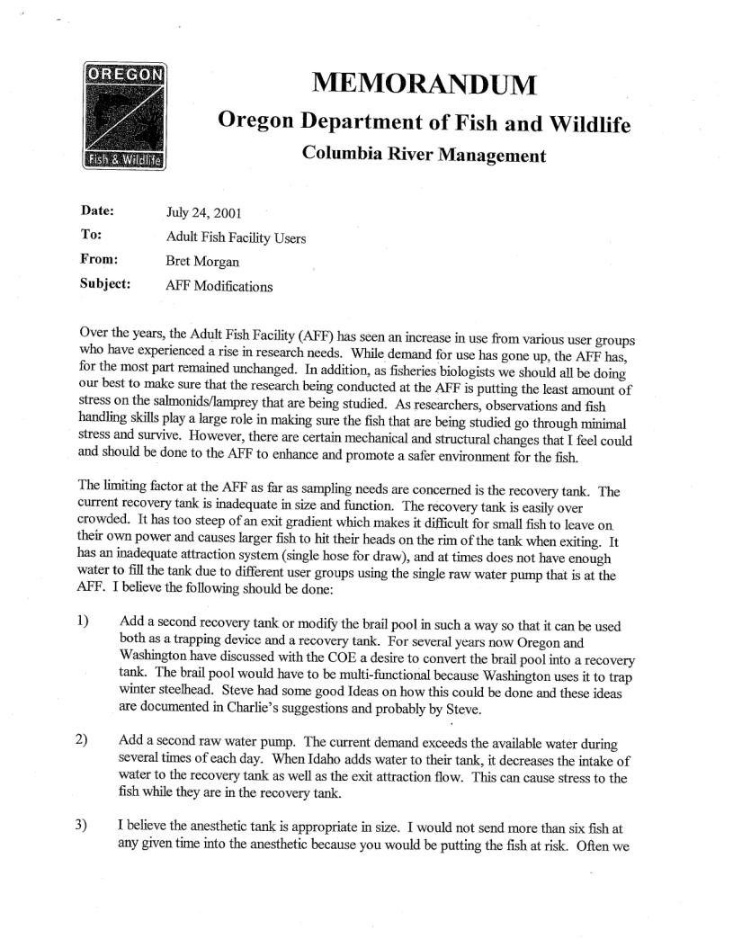

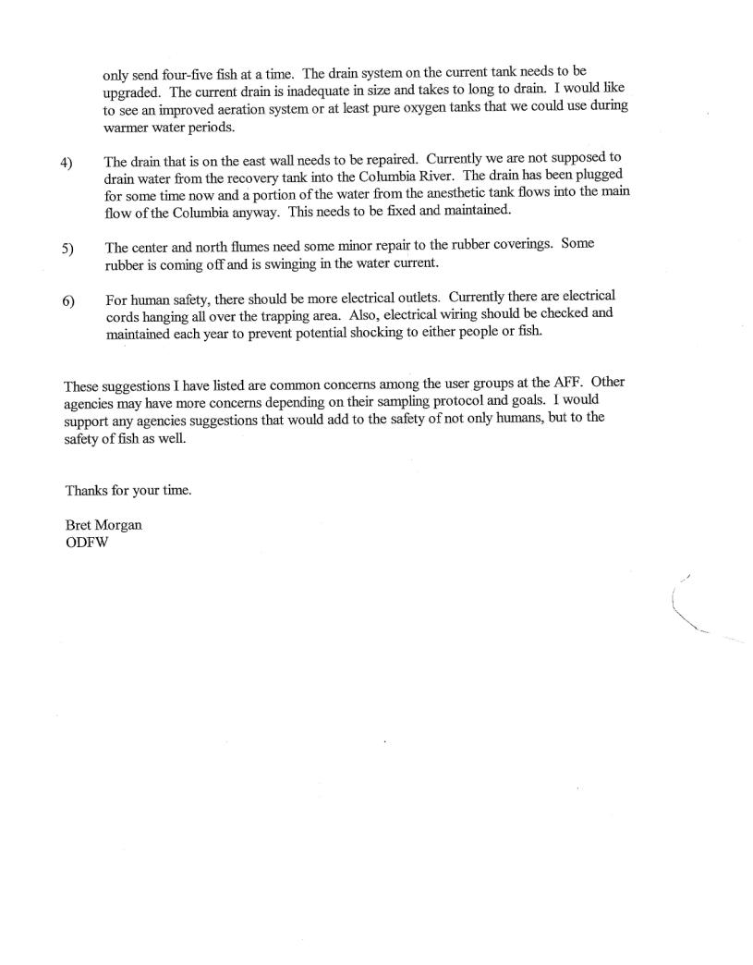
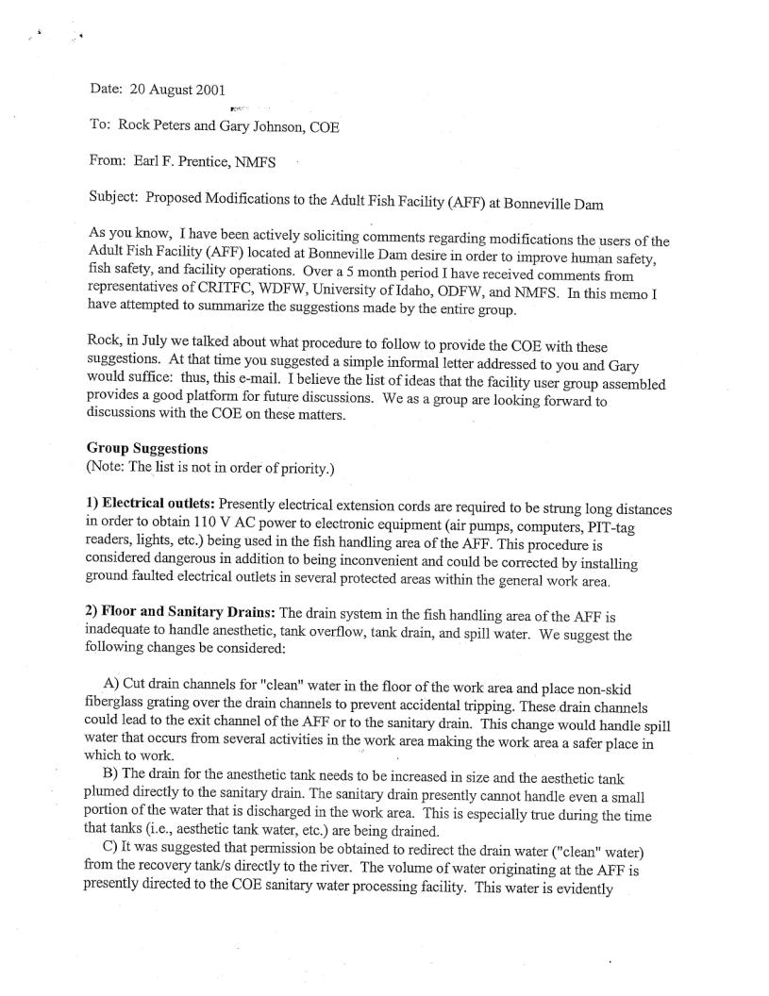
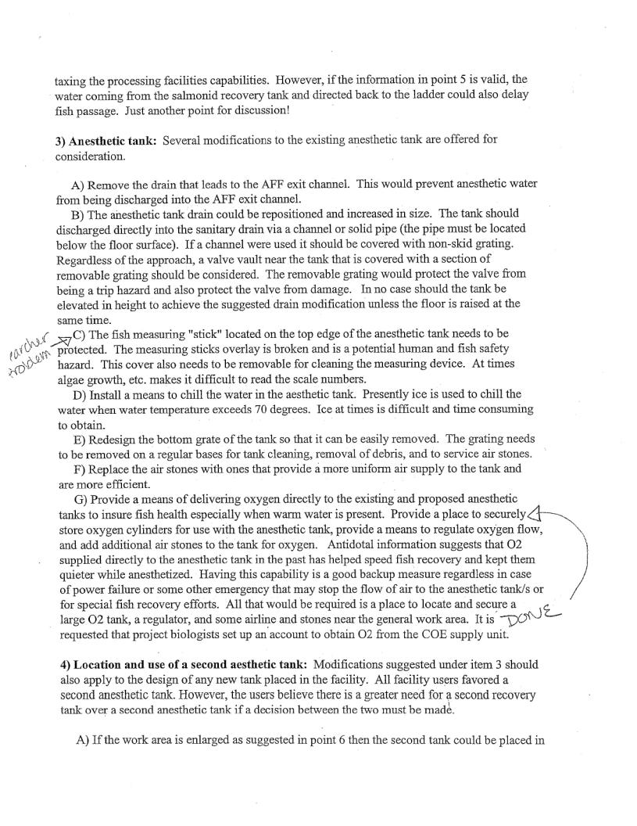
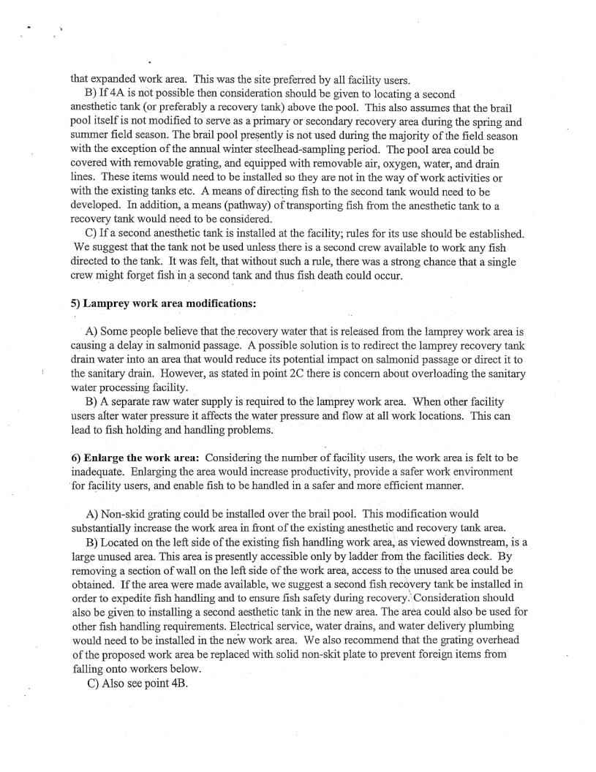
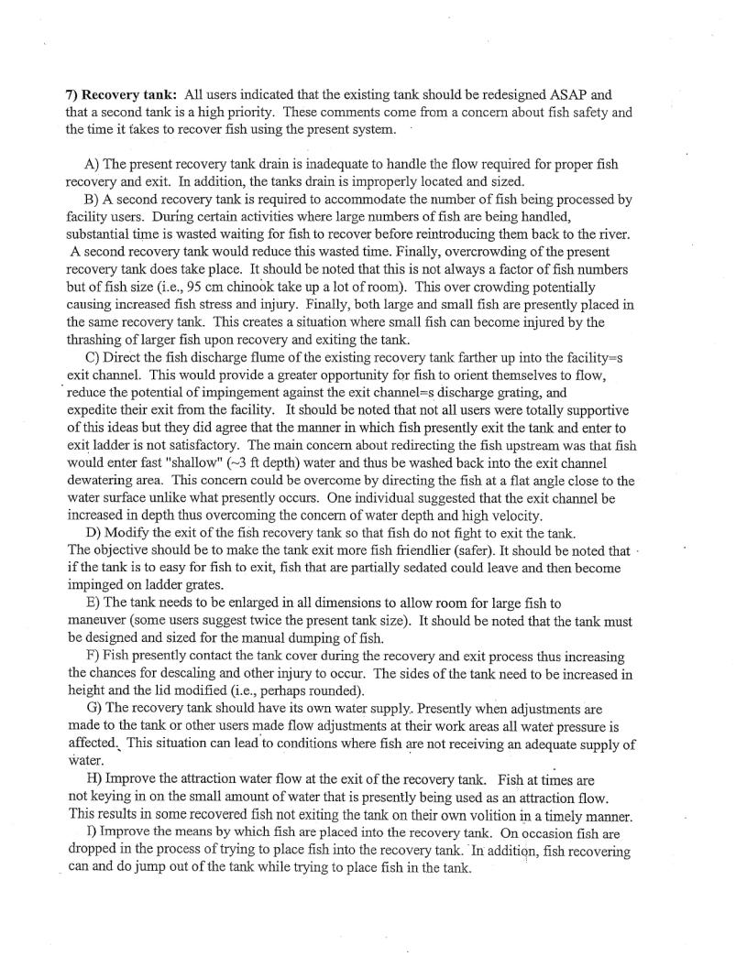
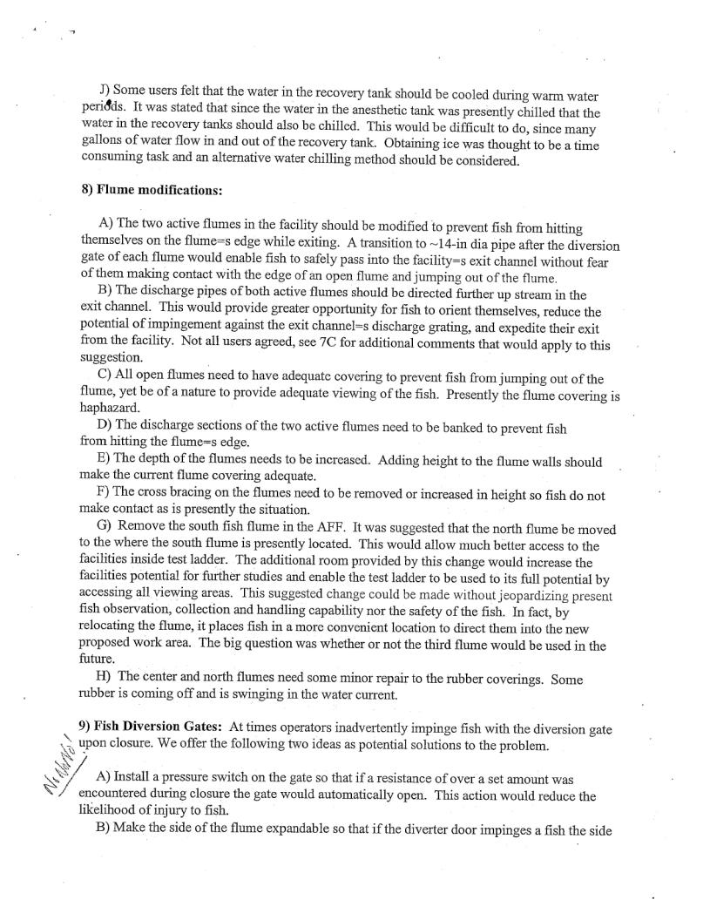
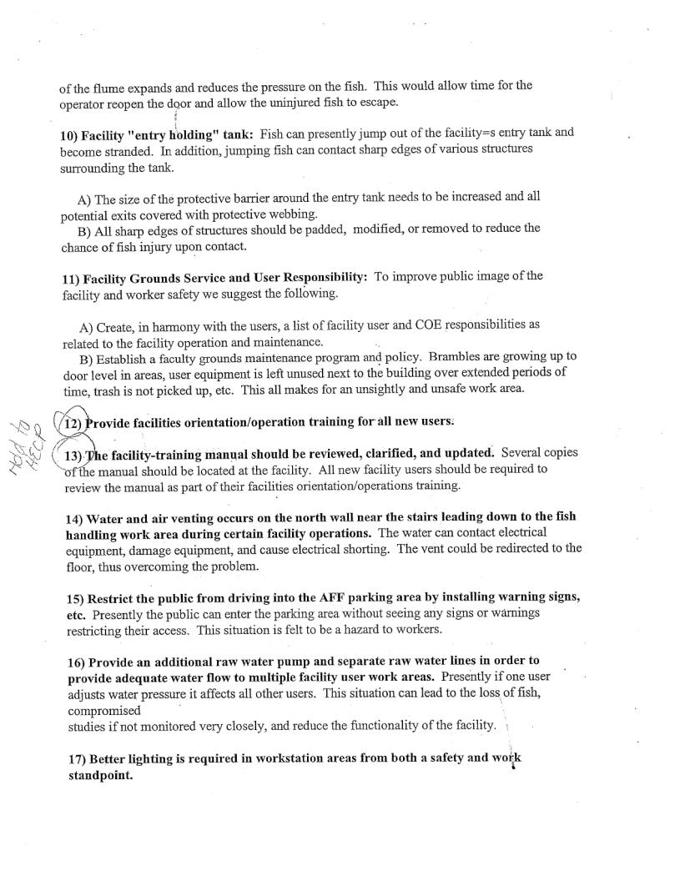
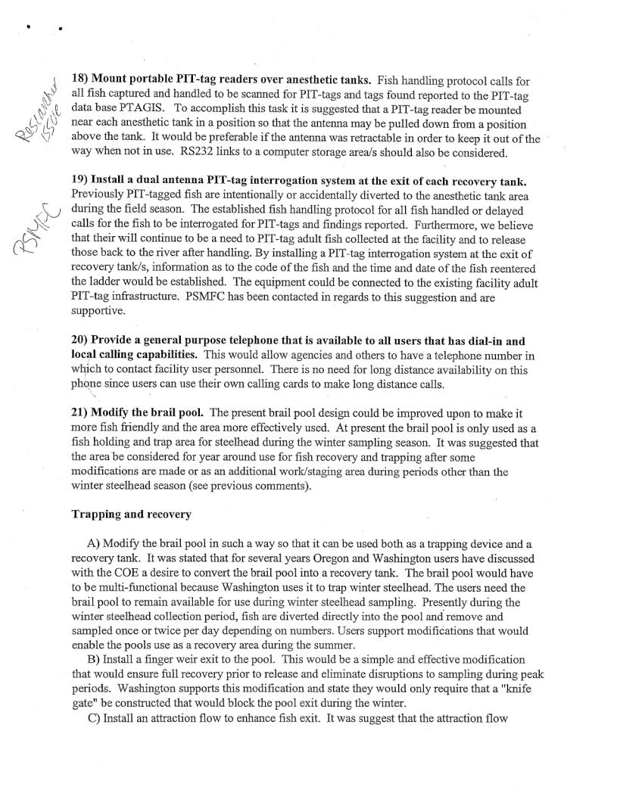
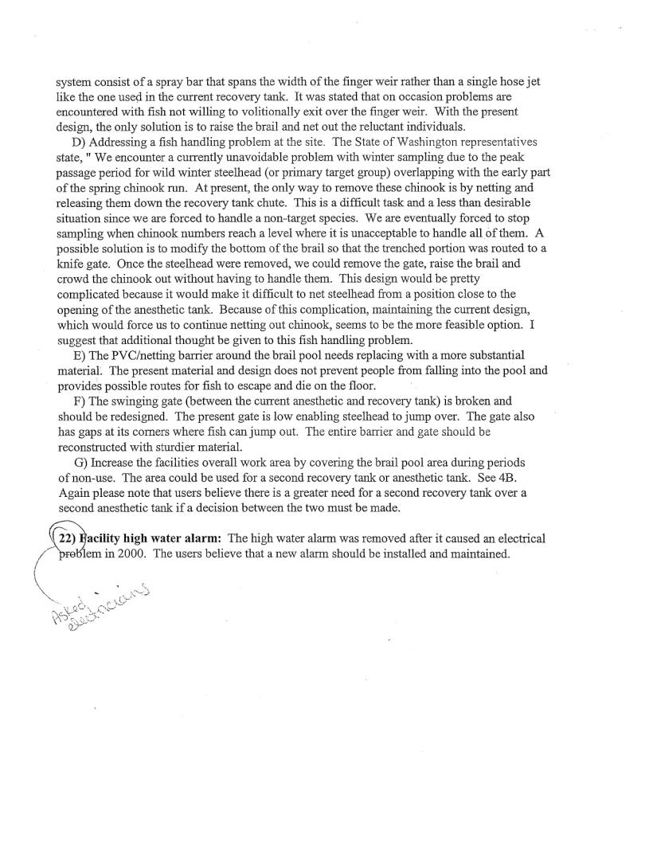

Small issues that could be dealt with in the near future-
- Do we still need the lamprey flume? It was suggested the flume may have outlived it’s usefulness at the AFF. Clugston will look into the need or lack of and possibility of removing it. Lorz suggests moving this to the lamprey task group for decision.
- The anesthetic tank has a small drain on the east side. Could that be replaced so the tank drains faster? USACE recommended attaching a hose to the larger west drain and running it to the wall drain. This would be easier and cheaper than trying to get the tank re-plumbed.
- The wall drain drains slowly. USACE reported that mechanics and plumbers have looked at that drain. No one seems to be able to determine the problem but they will look at it again this winter and call in a professional to snake it.
- The brail pool has a gap between the exit gate and the floor. The gap allows steelhead to get under the brail. The team looked at the gap. It may require major modifications to the brail pool.
- Check on environmental permits for clove oil (100% eugenol). This was discussed but it was decided that it may not be worth poking around at this issue just yet.
- Rubber flat at end of ramp to anesthesia tank needs modification for all sizes/species of fish that enter. The team looked at this. USACE committed to looking at different weights of neoprene, but the researchers may need to prepare to manually lift the flap when sampling smaller fish.
- Reduced flow to the AFF. USACE will request the Riggers clean the FERL intake screen (located just north of the fish units, in the forebay).

Larger and long term issues-
- CRITFC requested a facility at the count windows. Due to the space limitations there, it would be very difficult to get a handling facility in the fish viewing window area of the visitor center.
- NOAA Fisheries suggested razing the building and starting over. They would also like to see reduced reliance on the AFF.
- Need to assemble a task force to look at the future need; the need for sorting, handling, properly sizing tanks and providing enough water.
- Need to meet with TAC-Harvest to discuss future use.
- There may be a group working on the Basin-wide sampling/tagging. It was suggested the AFF team find this group and see if efforts could be coordinated, especially when it comes to tagging fish needed by CRITFC for harvest management. Also find the PIT tag group working on tag analyses; find out status

